**Data Visualization and Pre-processing**

**Assignment -2**

| Assignment Date | 26 September 2022 |
| --- | --- |
| Team ID | PNT2022TMID27812 |
| Project Name | Smart Lender - Applicant Credibility Prediction for Loan Approval |
| Student Name | S.G.Mydhrayan |
| Student Roll Number | 311519104036 |
| Maximum Marks | 2 Marks |

**Question-1.**Download dataset

**Solution:**

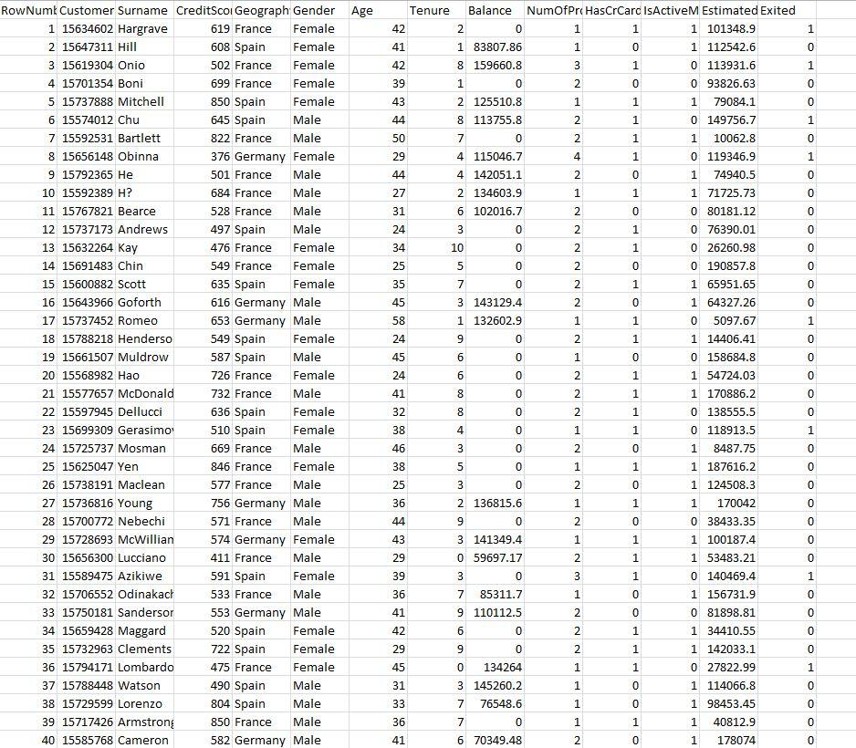

**Question-2.**Load the dataset

**Solution:**

**import numpy as np**

**import pandas as pd**

**import seaborn as sns**

**importmatplotlib.pyplot as plt**

**import sklearn**

**data = pd.read_csv(r'Churn_Modelling.csv')**

**df.head**

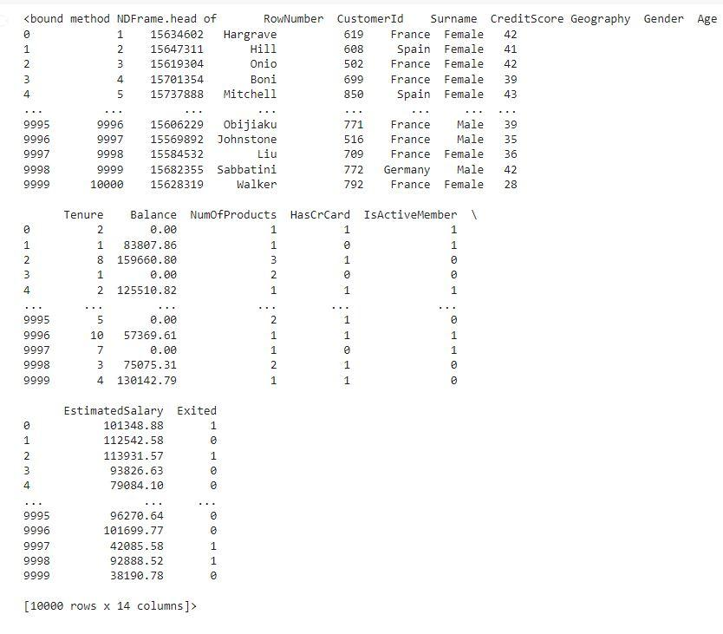

**Question-3.**Perform Below Visualizations.

***3.1 Univariate Analysis***

**Solution:**

**sns.displot(data['CreditScore'])**

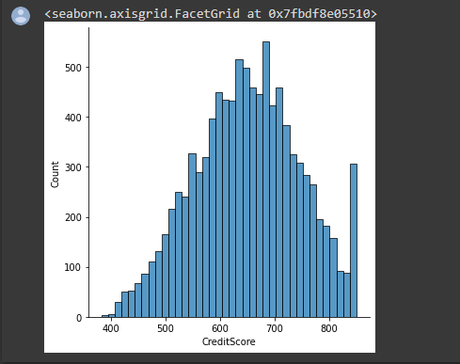

**sns.histplot(data['CreditScore'])**

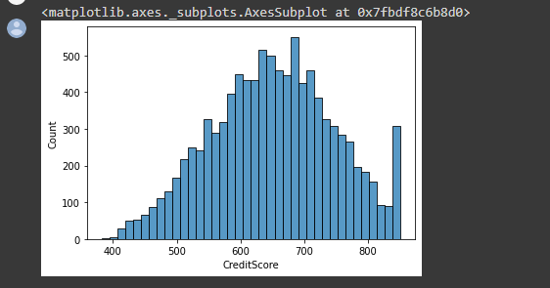

**sns.boxplot(x = data['CreditScore'])**

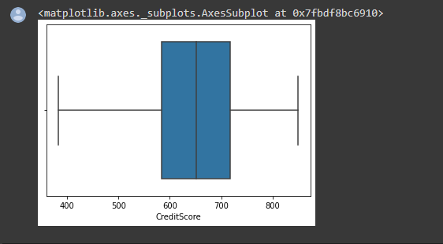

**sns.distplot(data['Age'])**

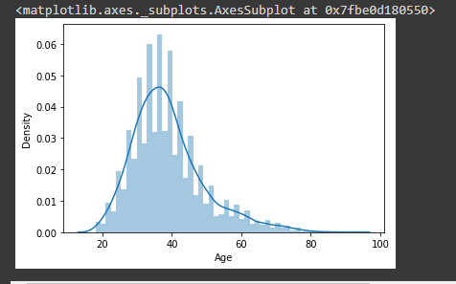

**sns.histplot(data['Age'])**

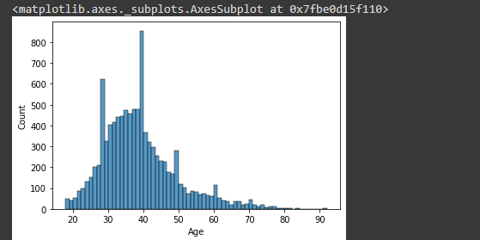

**sns.boxplot(data['Age'])**

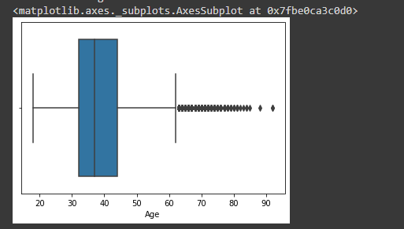

***3.2 Bivariate Analysis***

**Solution:**

**plt.figure(figsize=(7,7))**

**sns.lineplot(data = data, x = 'Tenure', y = 'CreditScore')**

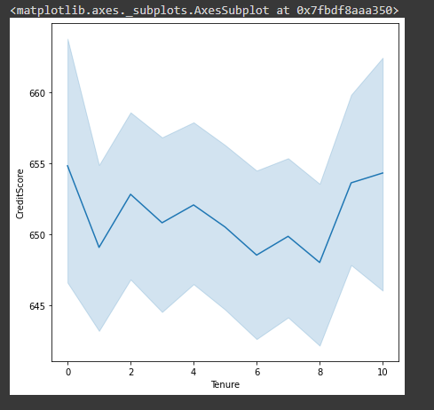

**plt.figure(figsize=(10,10))**

**sns.barplot(data = data, x = 'CreditScore', y ='EstimatedSalary')**

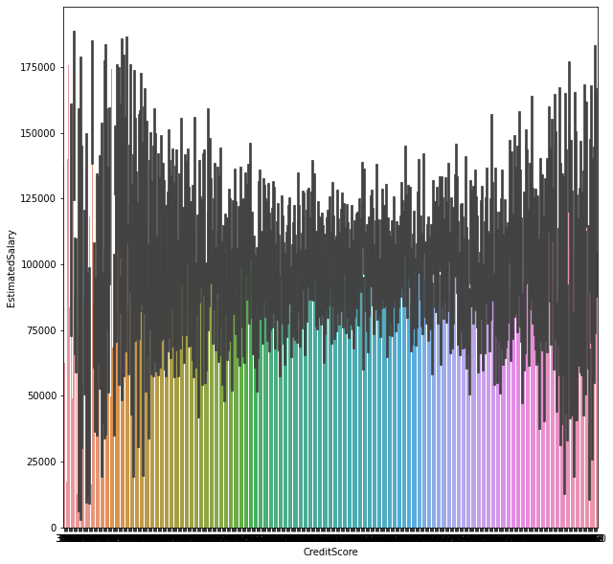

**plt.figure(figsize=(10,10))**

**sns.barplot(data = data, x = 'CreditScore', y = 'Tenure')**

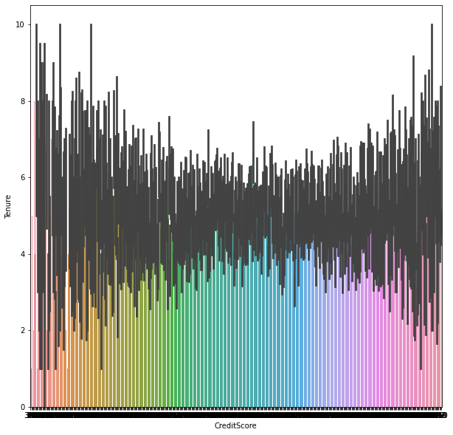

**plt.figure(figsize=(10,10))**

**sns.lineplot(data['Age'], data['EstimatedSalary'])**

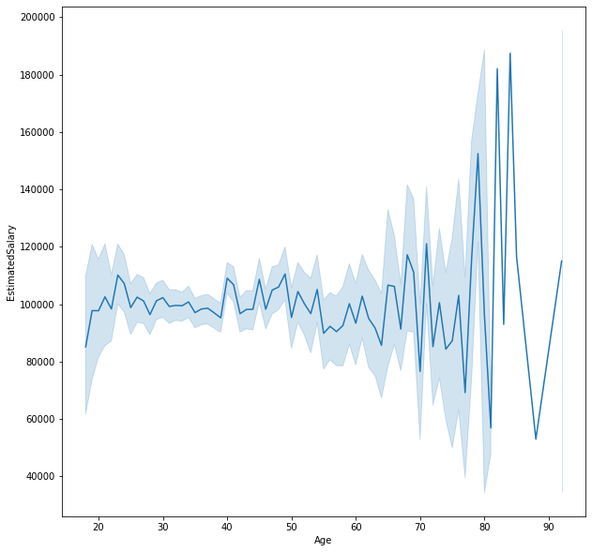

**plt.figure(figsize=(17,17))**

**sns.barplot(data['Age'], data['EstimatedSalary'])**

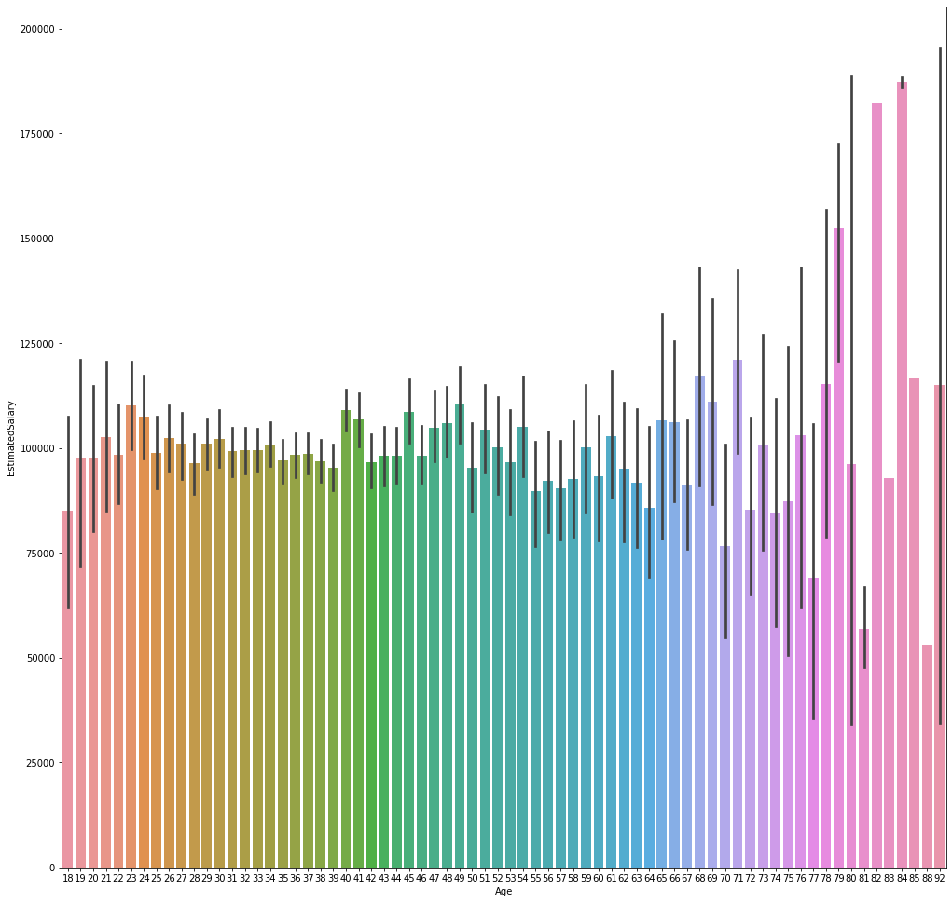

**sns.scatterplot(data = data, x = 'CreditScore', y = 'Age')**

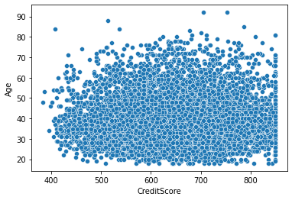

***3.3 Multivariate Analysis***

**Solution:**

**sns.scatterplot(data = data, x = 'CreditScore', y = 'Balance', hue = 'Gender')**

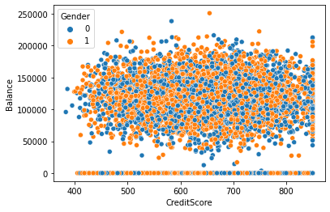

**sns.scatterplot(data['Tenure'], data['CreditScore'], hue = data['Gender'])**

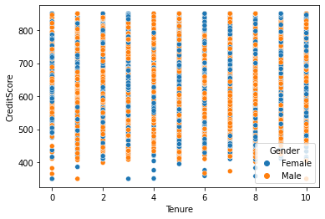

**sns.scatterplot(data['Age'], data['Balance'], hue = data['Gender'])**

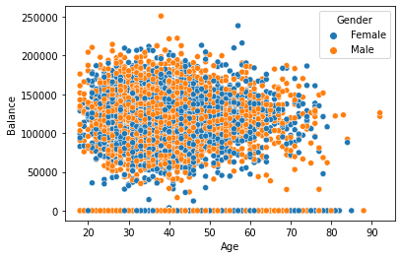

**sns.pairplot(data)**

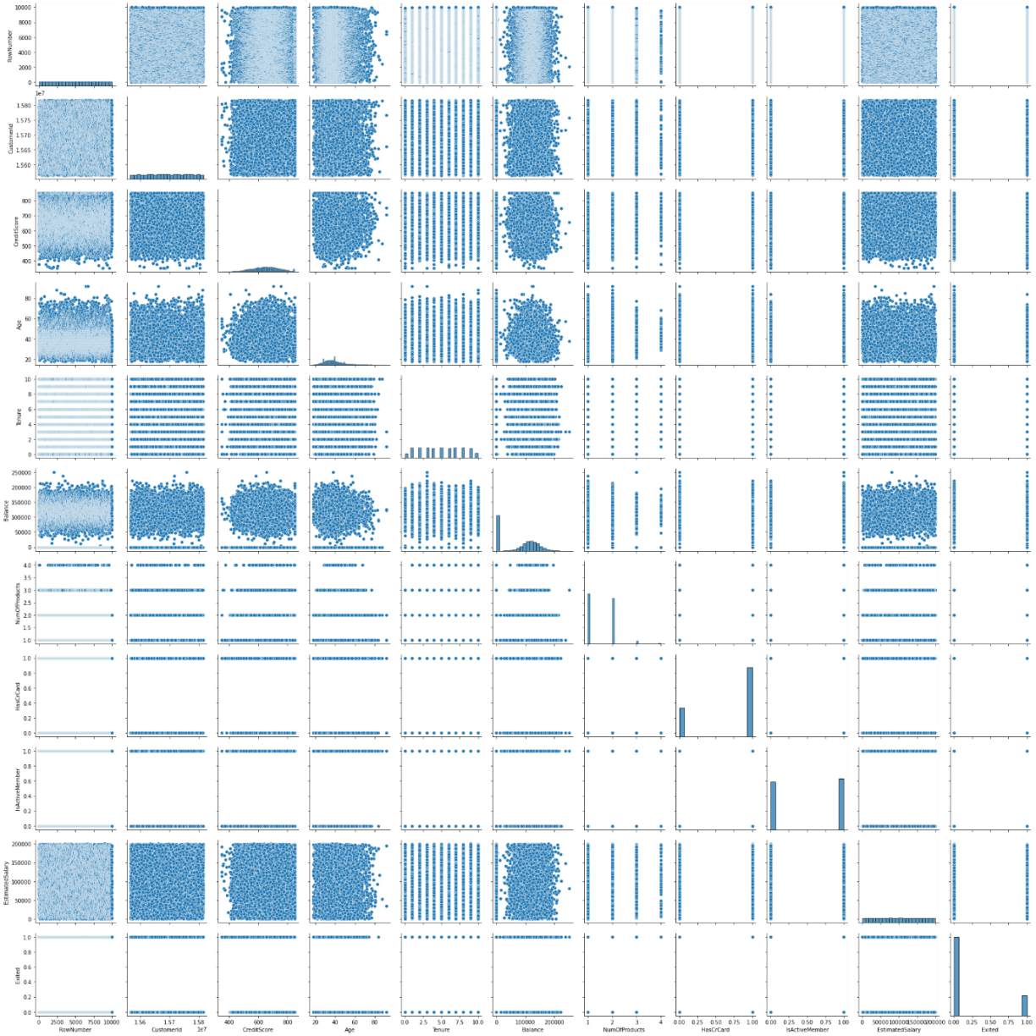

**Question-4.**Perform descriptive statistics on the dataset.

**Solution:**

**data.mean(numeric_only = True)**

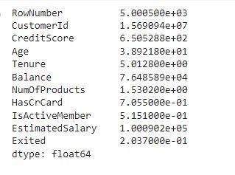

**data.median(numeric_only = True)**

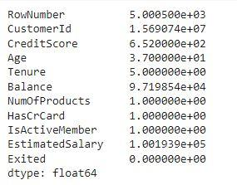

**data['CreditScore'].mode()**



**data['EstimatedSalary'].mode()**



**data['HasCrCard'].unique()**



**data['Tenure'].unique()**



**data.std(numeric_only=True)**

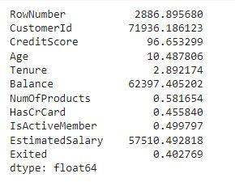

**data.describe()**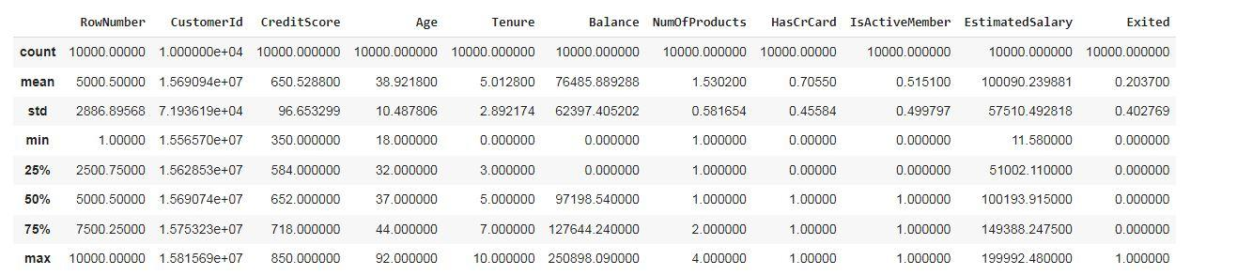

**data['Tenure'].value_counts()**

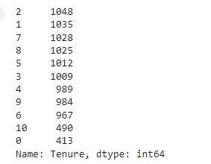

**Question-5.**Handle the Missing values.

**Solution:**

**data.isnull().any()**

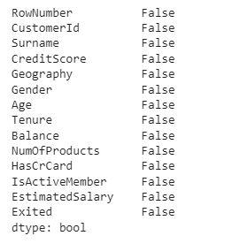

**data.isnull().sum()**

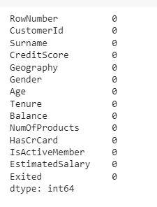

**Question-6.**Find the outliers and replace the outliers

**Solution:**

**sns.boxplot(data['CreditScore'])#Outlier detection - box plot**

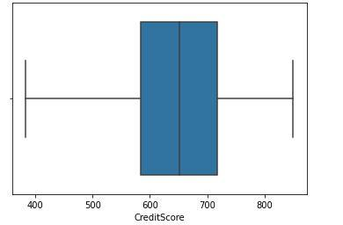

**fig, ax = plt.subplots(figsize = (5,3)) #Outlier detection - Scatter plot**

**ax.scatter(data['Balance'], data['Exited'])**

**# x-axis label**

**ax.set_xlabel('Balance')**

**# y-axis label**

**ax.set_ylabel('Exited')**

**plt.show()**

**sns.boxplot(x=data['Balance'])**

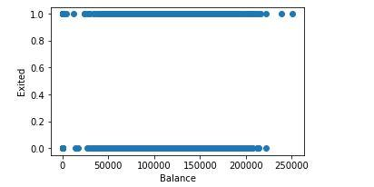

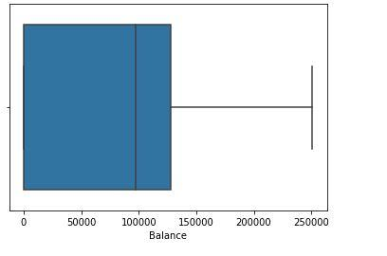

**from scipy import stats #Outlier detection – zscore**

**zscore = np.abs(stats.zscore(data['CreditScore']))**

**print(zscore)**

**print('No. of Outliers : ', np.shape(np.where(zscore>3)))**

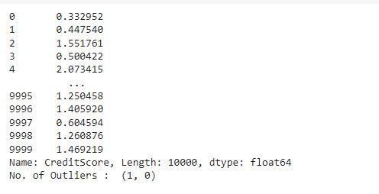

**q = data.quantile([0.75,0.25])**

**q**



**iqr =  q.iloc[0] - q.iloc[1]**

**iqr**

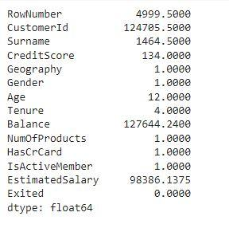

**u = q.iloc[0] + (1.5*iqr)**

**u**

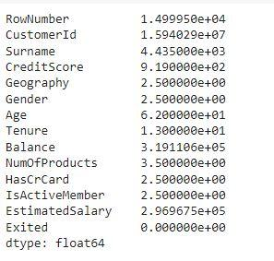

**l = q.iloc[1] - (1.5*iqr)**

**l**

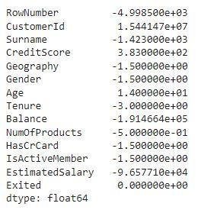

**Q1 = data['EstimatedSalary'].quantile(0.25) #Outlier detection - IQR**

**Q3 = data['EstimatedSalary'].quantile(0.75)**

**iqr = Q3 - Q1**

**print(iqr)**

**upper=Q3 + 1.5 * iqr**

**lower=Q1 - 1.5 * iqr**

**count = np.size(np.where(data['EstimatedSalary'] >upper))**

**count = count + np.size(np.where(data['EstimatedSalary'] <lower))**

**print('No. of outliers : ', count)**



**data['CreditScore'] = np.where(np.logical_or(data['CreditScore']>900, data['CreditScore']<383), 650, data['CreditScore'])**

**sns.boxplot(data['CreditScore'])**

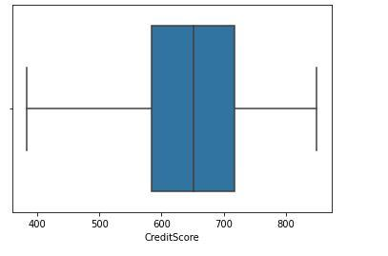

**upper = data.Age.mean() + (3 * data.Age.std()) #Outlier detection - 3 sigma**

**lower = data.Age.mean() - (3 * data.Age.std())**

**columns = data[ ( data['Age'] > upper ) | ( data['Age']<lower ) ]**

**print('Upper range : ', upper)**

**print('Lower range : ', lower)**

**print('No. of Outliers : ', len(columns))**

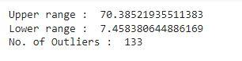

**columns = ['EstimatedSalary', 'Age', 'Balance', 'NumOfProducts', 'Tenure', 'CreditScore'] #After outlier removal**

**for i in columns:**

**Q1 = data[i].quantile(0.25)**

**Q3 = data[i].quantile(0.75)**

**iqr = Q3 - Q1**

**upper=Q3 + 1.5 * iqr**

**lower=Q1 - 1.5 * iqr**

**count = np.size(np.where(data[i] >upper))**

**count = count + np.size(np.where(data[i] <lower))**

**print('No. of outliers in ', i, ' : ', count)**

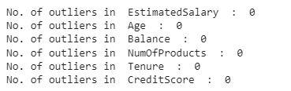

**Question-7.** Check for Categorical columns and perform encoding

**Solution:**

**from sklearn.preprocessing import LabelEncoder, OneHotEncoder**

**le = LabelEncoder()**

**oneh = OneHotEncoder()**

**data['Surname'] = le.fit_transform(data['Surname'])**

**data['Gender'] = le.fit_transform(data['Gender'])**

**data['Geography'] = le.fit_transform(data['Geography'])**

**data.head()**

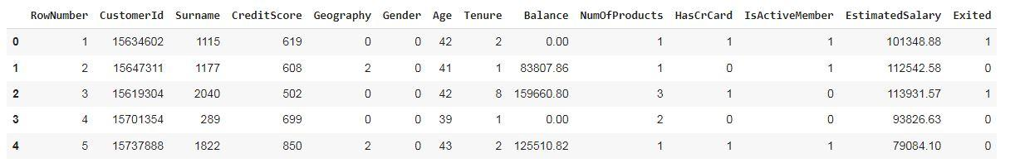

**Question-8.**Split the data into dependent and independent variables split the data in X and Y

**Solution:**

**x # independent values ( inputs)**

**x = data.iloc[:, 0:13]**

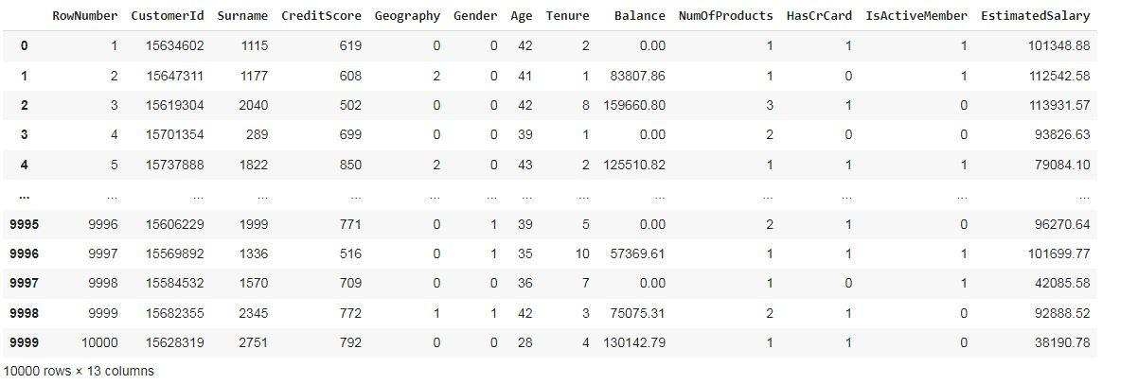

**y # dependent values (output)**

**y = data['Exited']**

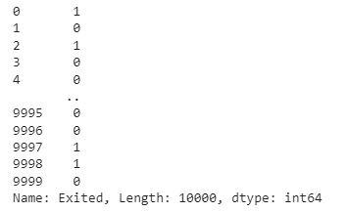

**Question-9.**Scale the independent variables

**Solution:**

**from sklearn.preprocessing import StandardScaler, MinMaxScaler**

**sc = StandardScaler()**

**x_scaled = sc.fit_transform(x)**

**x_scaled**

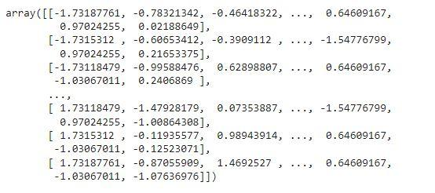

**Question-10.**Split x and y into Training and Testing

**Solution:**

**from sklearn.model_selection import train_test_split**

**x_train, x_test, y_train, y_test = train_test_split(x_scaled, y, test_size = 0.3, random_state = 0)**

**x_train**

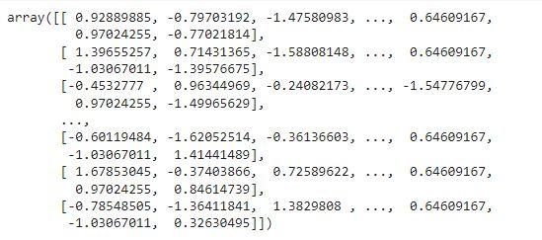

**x_train.shape**



**x_test**

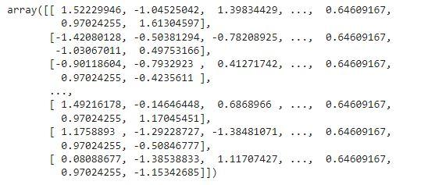

**x_test.shape**



**y_train**

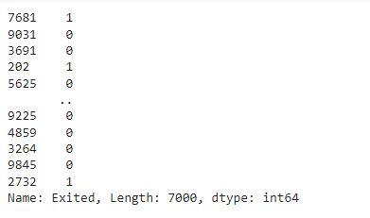

**y_test**

